Laboratorium 1,2: Oracle PL/SQL

Adam Mężydło

Spis treści

Tabele 2

Country 2

Person 2

Trip 2

Reservation 3

Log 3

Przykładowe dane 4

Country 4

Person 4

Trip 5

Reservation 5

Widoki 6

Reservations 6

Reservations1 6

Trips 7

AvailableTrips 7

Przykładowe użycia 7

Reservations 7

Reservations1 8

Trips 8

AvailableTripsView 8

Komentarz 8

Funkcje 9

TripParticipants 9

PersonReservations 10

AvailableTrips 11

Przykładowe wywołania 12

TripParticipants 12

PersonReservations 12

AvailableTripsView 12

AvailableTrips 12

Komentarz 12

# Tabele

## Country

create table country  
(  
 country_id int generated always as identity not null,  
 country_name varchar(50) not null,  
 constraint country_pk primary key (country_id) enable  
);

## Person

create table person  
(  
 person_id int generated always as identity not null,  
 firstname varchar(50),  
 lastname varchar(50),  
 constraint person_pk primary key ( person_id ) enable  
);

## Trip

create table trip  
(  
 trip_id int generated always as identity not null,  
 trip_name varchar(100),  
 country_id int,  
 trip_date date,  
 max_no_places int,  
 constraint trip_pk primary key ( trip_id ) enable  
);  
  
alter table trip  
add constraint country_fk foreign key  
(country_id) references country (country_id) enable;

## Reservation

create table reservation  
(  
 reservation_id int generated always as identity not null,  
 trip_id int,  
 person_id int,  
 status char(1),  
 constraint reservation_pk primary key ( reservation_id ) enable  
);  
  
  
alter table reservation  
add constraint reservation_fk1 foreign key  
( person_id ) references person ( person_id ) enable;  
  
alter table reservation  
add constraint reservation_fk2 foreign key  
( trip_id ) references trip ( trip_id ) enable;  
  
alter table reservation  
add constraint reservation_chk1 check  
(status in ('N','P','C')) enable;

## Log

create table log  
(  
 log_id int generated always as identity not null,  
 reservation_id int not null,  
 log_date date not null,  
 status char(1),  
 constraint log_pk primary key ( log_id ) enable  
);  
  
alter table log  
add constraint log_chk1 check  
(status in ('N','P','C')) enable;  
  
alter table log  
add constraint log_fk1 foreign key  
( reservation_id ) references reservation ( reservation_id ) enable;

# Przykładowe dane

## Country

insert into country(COUNTRY_NAME)  
values ('Francja');  
  
insert into country(COUNTRY_NAME)  
values ('Polska');  
  
insert into country(COUNTRY_NAME)  
values ('Niemcy');  
  
insert into country(COUNTRY_NAME)  
values ('Belgia');  
  
insert into country(COUNTRY_NAME)  
values ('Egipt');

## Person

insert into person(firstname, lastname)  
values ('Jan', 'Nowak');  
  
insert into person(firstname, lastname)  
values ('Jan', 'Kowalski');  
  
insert into person(firstname, lastname)  
values ('Jan', 'Nowakowski');  
  
insert into person(firstname, lastname)  
values ('Adam', 'Kowalski');  
  
insert into person(firstname, lastname)  
values ('Novak', 'Nowak');

## Trip

insert into trip(trip_name, country_id, trip_date, max_no_places)  
values ('Lonely trip', 3, *to_date*('2024-11-01', 'YYYY-MM-DD'), 1);  
  
insert into trip(trip_name, country_id, trip_date, max_no_places)  
values ('Auslander', 3, *to_date*('2023-04-03', 'YYYY-MM-DD'), 3);  
  
insert into trip(trip_name, country_id, trip_date, max_no_places)  
values ('W poszukiwaniu Faraona', 5, *to_date*('2022-05-01', 'YYYY-MM-DD'), 5);  
  
insert into trip(trip_name, country_id, trip_date, max_no_places)  
values ('U nas na Podlasiu', 2, *to_date*('2023-04-06', 'YYYY-MM-DD'), 5);  
  
insert into trip(trip_name, country_id, trip_date, max_no_places)  
values ('Disnayland', 1, *to_date*('2026-12-25', 'YYYY-MM-DD'), 2);

## Reservation

insert into reservation(trip_id, person_id, status)  
values (2, 1, 'P');  
  
insert into reservation(trip_id, person_id, status)  
values (2, 4, 'C');  
  
insert into reservation(trip_id, person_id, status)  
values (3, 4, 'P');  
  
insert into reservation(trip_id, person_id, status)  
values (3, 5, 'P');  
  
insert into reservation(trip_id, person_id, status)  
values (3, 6, 'C');  
  
insert into reservation(trip_id, person_id, status)  
values (4, 1, 'N');  
  
insert into reservation(trip_id, person_id, status)  
values (4, 9, 'N');  
  
insert into reservation(trip_id, person_id, status)  
values (5, 10, 'P');

# Widoki

## Reservations

create or replace view Reservations  
as  
select c.country_name,  
 t.trip_date,  
 t.trip_name,  
 p.firstname,  
 p.lastname,  
 r.reservation_id,  
 r.status  
from country c  
 join trip t on c.COUNTRY_ID = t.COUNTRY_ID  
 join reservation r on r.TRIP_ID = t.TRIP_ID  
 join person p on p.PERSON_ID = r.PERSON_ID;

## Reservations1

create or replace view Reservations1  
as  
select c.country_name,  
 t.trip_date,  
 t.trip_name,  
 t.trip_id,  
 p.firstname,  
 p.lastname,  
 p.person_id,  
 r.reservation_id,  
 r.status  
from country c  
 join trip t on c.COUNTRY_ID = t.COUNTRY_ID  
 join reservation r on r.TRIP_ID = t.TRIP_ID  
 join person p on p.PERSON_ID = r.PERSON_ID;

## Trips

create or replace view Trips  
as  
select c.country_name,  
 t.TRIP_DATE,  
 t.TRIP_NAME,  
 t.MAX_NO_PLACES,  
 *nvl*(t.MAX_NO_PLACES - (select *count*(rw.RESERVATION_ID)  
 from reservation rw  
 join trip tw on rw.trip_id = tw.trip_id  
 where rw.status != 'C'  
 and t.trip_id = tw.trip_id  
 group by rw.Trip_id), t.MAX_NO_PLACES) no_available_places  
from trip t  
 join reservation r on t.trip_id = r.reservation_id  
 join country c on t.COUNTRY_ID = c.COUNTRY_ID;

## Trips1

create or replace view Trips1  
as  
select c.country_name,  
 t.TRIP_DATE,  
 t.TRIP_NAME,  
 t.trip_id,  
 t.MAX_NO_PLACES,  
 *nvl*(t.MAX_NO_PLACES - (select *count*(rw.RESERVATION_ID)  
 from reservation rw  
 join trip tw on rw.trip_id = tw.trip_id  
 where rw.status != 'C'  
 and t.trip_id = tw.trip_id  
 group by rw.Trip_id), t.MAX_NO_PLACES) no_available_places  
from trip t  
 join reservation r on t.trip_id = r.reservation_id  
 join country c on t.COUNTRY_ID = c.COUNTRY_ID;

## FutureTrips

create or replace view FutureTrips  
as  
select country_name,  
 trip_date,  
 trip_name,  
 trip_id,  
 max_no_places,  
 no_available_places  
from Trips1  
where trip_date > *current_date*;

## AvailableTrips

create or replace view AvailableTripsView  
as  
select country_name,  
 trip_date,  
 trip_name,  
 max_no_places,  
 no_available_places  
from trips  
where trip_date > *current_date* and no_available_places > 0

## AvailableTrips1

create or replace view AvailableTripsView1  
as  
select *  
from FutureTrips  
where no_available_places > 0;

## Przykładowe użycia

### Reservations

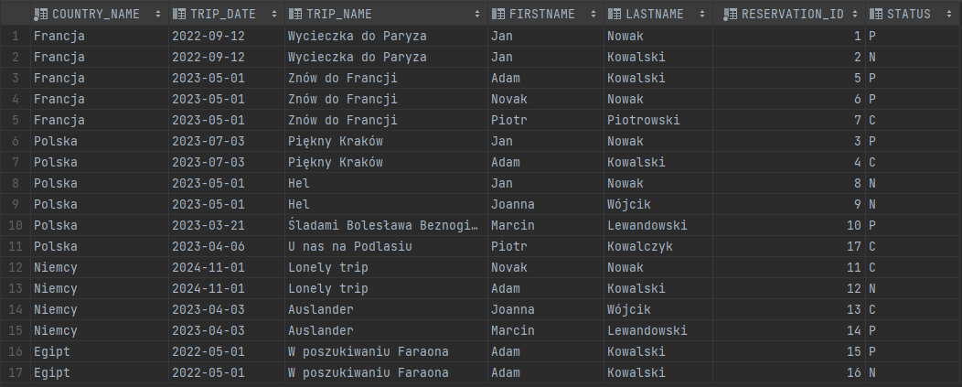

### Reservations1

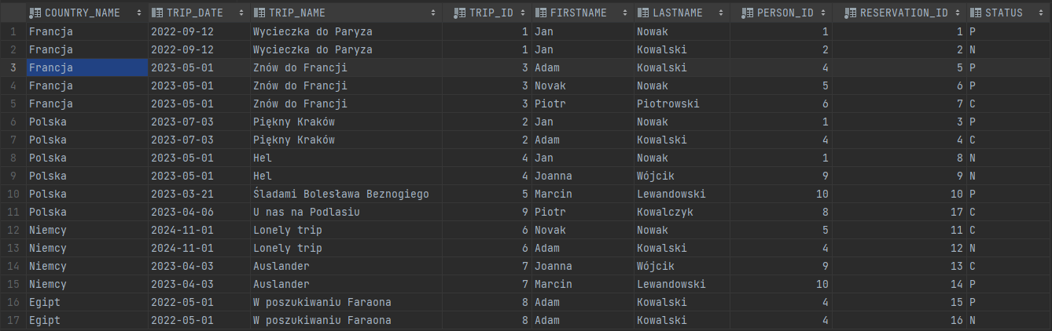

### Trips

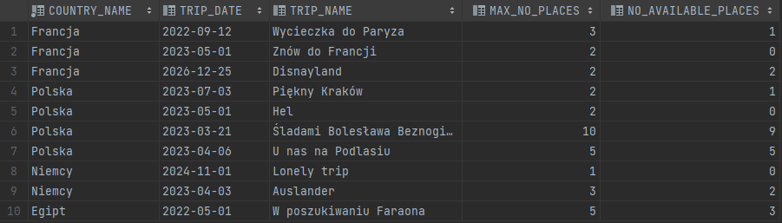

### AvailableTripsView

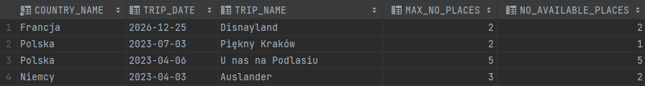

## Komentarz

Powyższe wyniki działania widoków uzyskane zostały 02.04.2023. Widok AvailableTrips został napisany wykorzystując wcześniej utworzony widok Trips w celu uniknięcia redundancji kodu. Zmieniono nazwę widoku *AvailableTrips* na *AvailableTripsView*, w celu uniknięcia konfliktu nazw z funkcją z kolejnego zadania. Dodany został widok *Reservations1*, który rozszerza pierwotny widok o dodatkowe pola potrzebne funkcjom.

# Funkcje

## TripParticipants

create or replace type TripParticipant as object  
(  
 country_name varchar2(50),  
 trip_date date,  
 trip_name varchar2(50),  
 firstname varchar2(50),  
 lastname varchar2(50),  
 reservation_id int,  
 status char(1)  
);  
  
  
create or replace type TripParticipantTable is table of TripParticipant;  
  
  
create or replace function *TripParticipants*(trip_id int)  
 return TripParticipantTable  
 is  
 result TripParticipantTable;  
 valid int;  
begin  
 select *count*(*) into valid from trip t where t.trip_id = *TripParticipants*.trip_id;  
 if valid = 0 then  
 *raise_application_error*(-20001, 'trip not found');  
 end if;  
  
 select TripParticipant(country_name,  
 trip_date,  
 trip_name,  
 firstname,  
 lastname,  
 reservation_id,  
 status) bulk collect  
 into result  
 from reservations1 r  
 where r.trip_id = *TripParticipants*.trip_id;  
  
 return result;  
end;

## PersonReservations

create or replace function *PersonReservations*(person_id int)  
 return TripParticipantTable  
 is  
 result TripParticipantTable;  
 valid int;  
begin  
 select *count*(*) into valid from person p where p.person_id = *PersonReservations*.person_id;  
 if valid = 0 then  
 *raise_application_error*(-20001, 'person not found');  
 end if;  
  
 select TripParticipant(country_name,  
 trip_date,  
 trip_name,  
 firstname,  
 lastname,  
 reservation_id,  
 status) bulk collect  
 into result  
 from reservations1 r  
 where r.person_id = *PersonReservations*.person_id;  
  
 return result;  
end;

## AvailableTrips

create or replace type AvailableTrip is object  
(  
 country_name varchar2(50),  
 trip_date date,  
 trip_name varchar2(50),  
 max_no_places int,  
 no_available_places int  
);  
  
create or replace type AvailableTripTable is table of AvailableTrip;  
  
  
  
create or replace function *AvailableTrips*(country varchar2, date_from date, date_to date)  
 return AvailableTripTable  
 is  
 result AvailableTripTable;  
 valid int;  
begin  
 select *count*(*) into valid from country c where c.country_name = *AvailableTrips*.country;  
 if valid = 0 then  
 *raise_application_error*(-20001, 'country not found');  
 end if;  
  
 select AvailableTrip(country_name,  
 trip_date,  
 trip_name,  
 max_no_places,  
 no_available_places) bulk collect  
 into result  
 from AVAILABLETRIPSVIEW  
 where COUNTRY_NAME = *AvailableTrips*.country  
 and trip_date between *AvailableTrips*.date_from and *AvailableTrips*.date_to;  
  
  
 return result;  
  
end;

## Przykładowe wywołania

### TripParticipants

select * from *TripParticipants*(3);



### PersonReservations

select * from *PERSONRESERVATIONS*(1);



### AvailableTripsView

select * from AVAILABLETRIPSVIEW where COUNTRY_NAME = 'Polska';



### AvailableTrips

select *  
from *AVAILABLETRIPS*('Polska',  
 *to_date*('2000-01-01', 'YYYY-MM-DD'),  
 *to_date*('2026-01-01', 'YYYY-MM-DD'));



## 

### CheckAvailablePlaces

create or replace function *CheckAvailablePlaces*(trip_id int)  
 return boolean  
 is  
 result boolean := false;  
 available_places int;  
begin  
 select atv.NO_AVAILABLE_PLACES  
 into available_places  
 from AVAILABLETRIPSVIEW1 atv  
 where atv.trip_id = *CheckAvailablePlaces*.trip_id;  
  
 if available_places <> 0 then  
 result := true;  
 end if;  
  
 return result;  
  
end;

## Komentarz

Powyższe funkcje zostały przetestowane dla różnych danych wejściowych, również niepoprawnych, które obsługiwane są za pomocą wyjątku. Funkcja TripParticipants zakłada, że wszystkie stany rezerwacji powinny być wyświetlone w zbiorze wynikowym. Powyższe wywołania związane z funkcją AvailableTrips pokazują działanie tej funkcji jako funkcji filtrującej dane po zakresie dat. W celu sprawdzenia, czy na daną wycieczkę są jeszcze wolne miejsca, powstała funkcja *CheckAvailablePlaces* zwracająca wartość boolean.

# Procedury